Review Worksheet #3
NAME Review Worksheet #3
Section 1 - Multiple Choice
For question 1
A plumber charges $75 to come out to the house, plus $12 for each hour of work.
Service | Amount Charged
Service Call | $75
Each Hour | $12
1)
If the bill was $111, how many hours did the plumber work?
(a) hours

(b)hours
- hours
- hours

For question 2
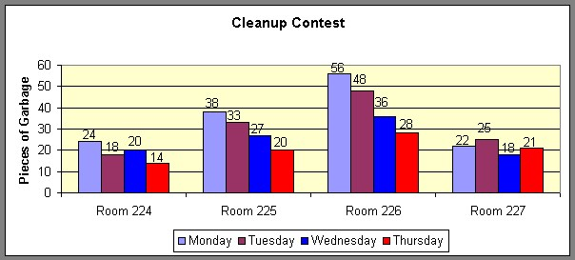
The seventh grade classes were having a problem keeping their homeroom floors clean. The janitors started a contest to see which room could leave the least amount of garbage on the floor at the end of the day. Here are

the results.
2)
If the patterns continue, which homeroom will have the least amount of trash on the floor on Friday?
(a) 224 (b) 225 (c) 226
(d) 227

3) June, Lily, Nicole, Taylor, Jennifer, and Haley made cookies for the bake sale at school. If the pattern is consistent, how many cookies did Nicole make?
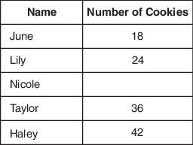
(a) 28 (b) 30 (c) 32
(d) 34

4) Use the following rule to make pairs of numbers .
Of the pairs shown below, which pair follows the rule above?
(a) (7, 2) (b) (9, 5)
- (10, 1)
- (11, 8)

5) What is the rule being followed in the pairs below?
(3, 4) (5, 6) (7, 8) (11, 9)
- odd, even
- add one
- prime, composite
- multiply by 3, subtract 5

6) What is the rule?
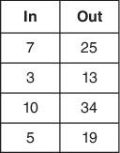
(a)

(b)

(c)
(d)
7) Malcolm was building a tower of blocks. The bottom block was yellow, the next was blue, then red, and then green. He kept repeating the pattern of colors. What color was the twenty-ninth block?
- yellow
- blue
- red
- green

8) Complete the T-chart by filling in the missing place.
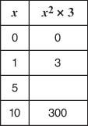
(a) 30
(b) 53
- 60
- 75
- What are the next four shapes in this pattern?
  - (c)
  - (d)
- Washington High School just started a tutoring program. On the first night of the tutoring, 2 people were present. On the second night, 6 people were present. On the third night, 14 people were present. If this follows the same pattern, how many people will be present for tutoring on the fourth night?
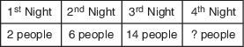
(a) 26
(b) 28
(c) 30
(d) 32

11) Four children bought ice cream cones. Each person ordered a different number of scoops of ice cream.
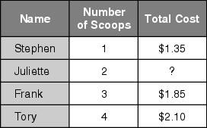
How much did Juliette’s double scoop cost?
(a) $1.45
(b) $1.50
- $1.55
- $1.60

12) Ahmad is trying to visit all 50 states. In 1995, he visited 2 states; in 1996, he visited 3 more states; in 1997, he visited 4 more states; and in 1998, he visited 5 more states. If he continues this pattern, in what year will he visit the 50th state?
(a) 2001
(b) 2003
(c) 2005
(d) 2007
- Which rule would complete this chart?
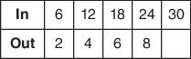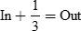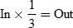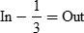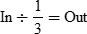
(
a
)
(
c
)
(
b
)
(
d
)
- What are the next three numbers in this number pattern?
2, 3, 6, 7, 14,
(a) 16, 32, 34
(b) 16, 32, 33
(c) 15, 30, 31
(d) 15, 32, 34

15) What is the next number in the following pattern?
1, 1, 2, 4, 3, 9, 4, 16, 5,
- 6
- 15
- 25
- 50

16) Julie is driving home from college. The table shows the time and distance she has traveled so far. If Julie continues to drive at the same rate, which equation can be used to find , the number of miles traveled in hours?
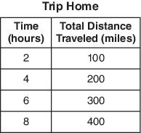
(a)
(b)
(c)
(d) 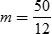

- Beth is 11 years old. Her sister, Nan, is 3. Beth made this table to show their ages over 3 years. How old will Beth be when she is twice Nan’s age?
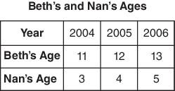
(a) 10
(b) 16
(c) 18
(d) 26
18) If you jump from point to point in alphabetical order, what is true of the y-coordinates?
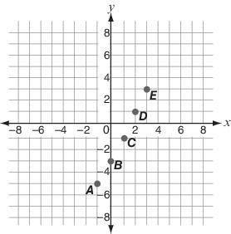
- They change by a different amount every time.
- They always increase by 1.
- They always increase by 2.
(d) They always decrease by 2.

- Which expression below is not equivalent to the other 3?
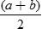
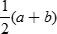
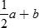
(a)
(b)
(c)
(d)

- Complete the T-chart by filling in the missing place.
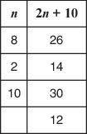

- 1
- 3
- 4
- 7

